ASSIGNMENT 5

AIM:

To design 3-input CMOS NAND Gate, 3-input CMOS NOR Gate and 2-input CMOS XOR Gate and study the effect of change of MOSFET sized on gate delays.
CIRCUIT:

1. CMOS 3-input NAND Gate has been constructed as follows-
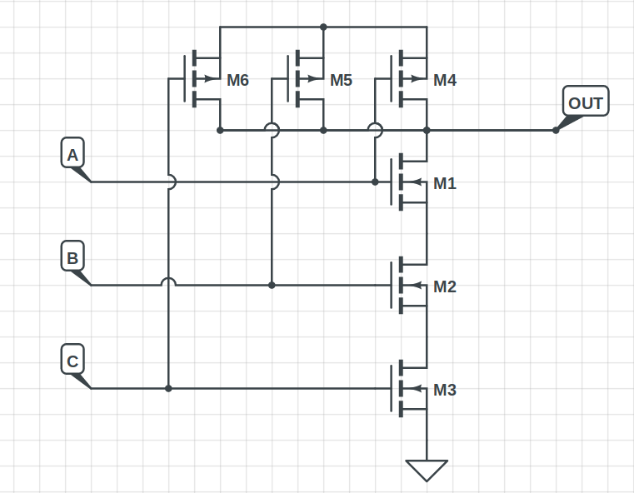

2. CMOS 3-input NOR Gate has been constructed as follows-
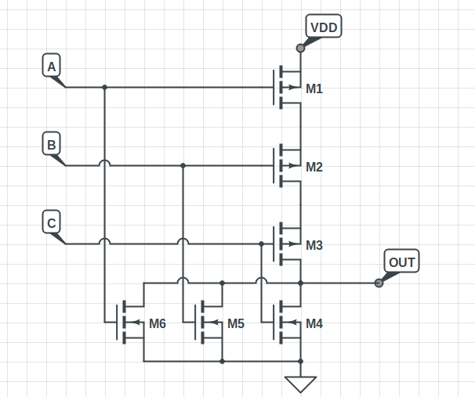
3. CMOS 2-input XOR Gate has been constructed using the 2-input NAND Gates(Q5-A) and NOT Gates(Q4) as follows-
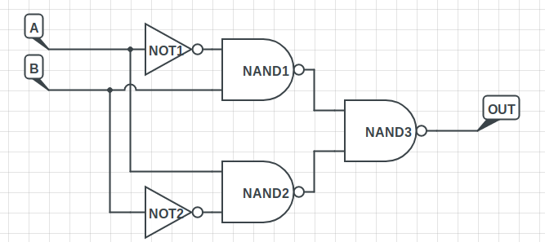

MAGIC LAYOUTS:

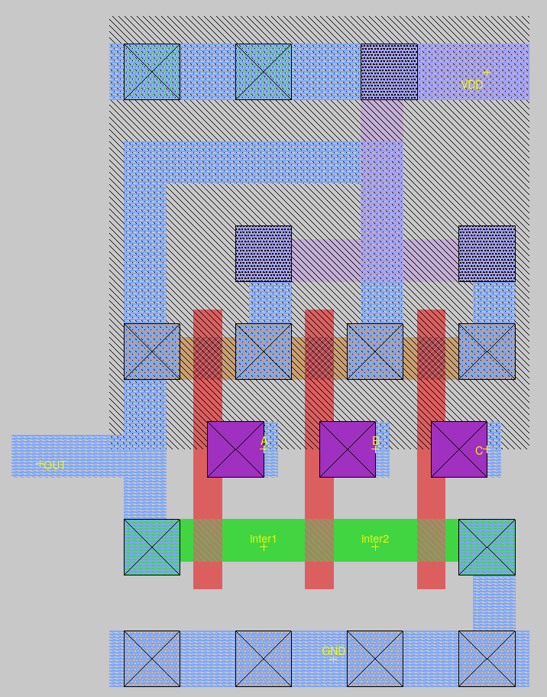
3-Input NAND Gate

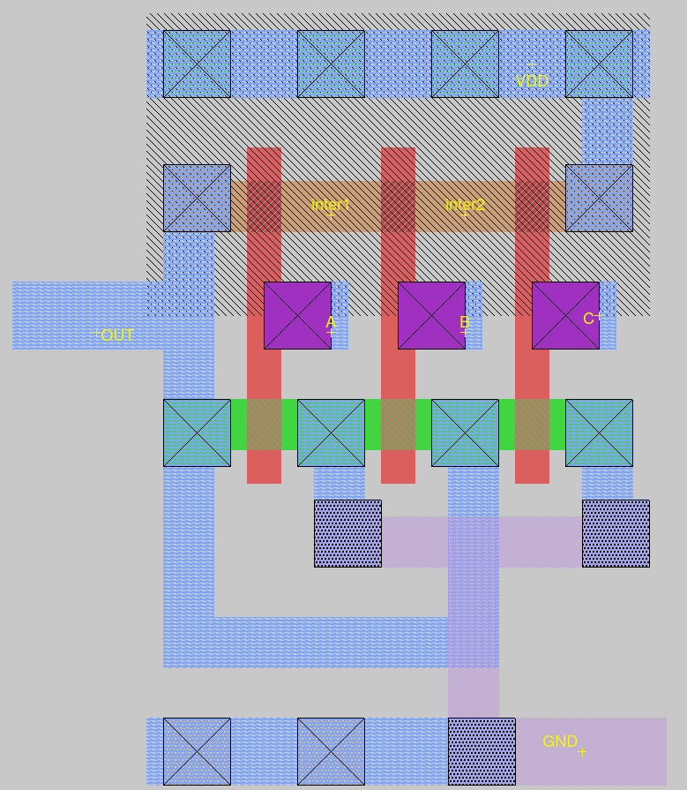
3-Input NOR Gate

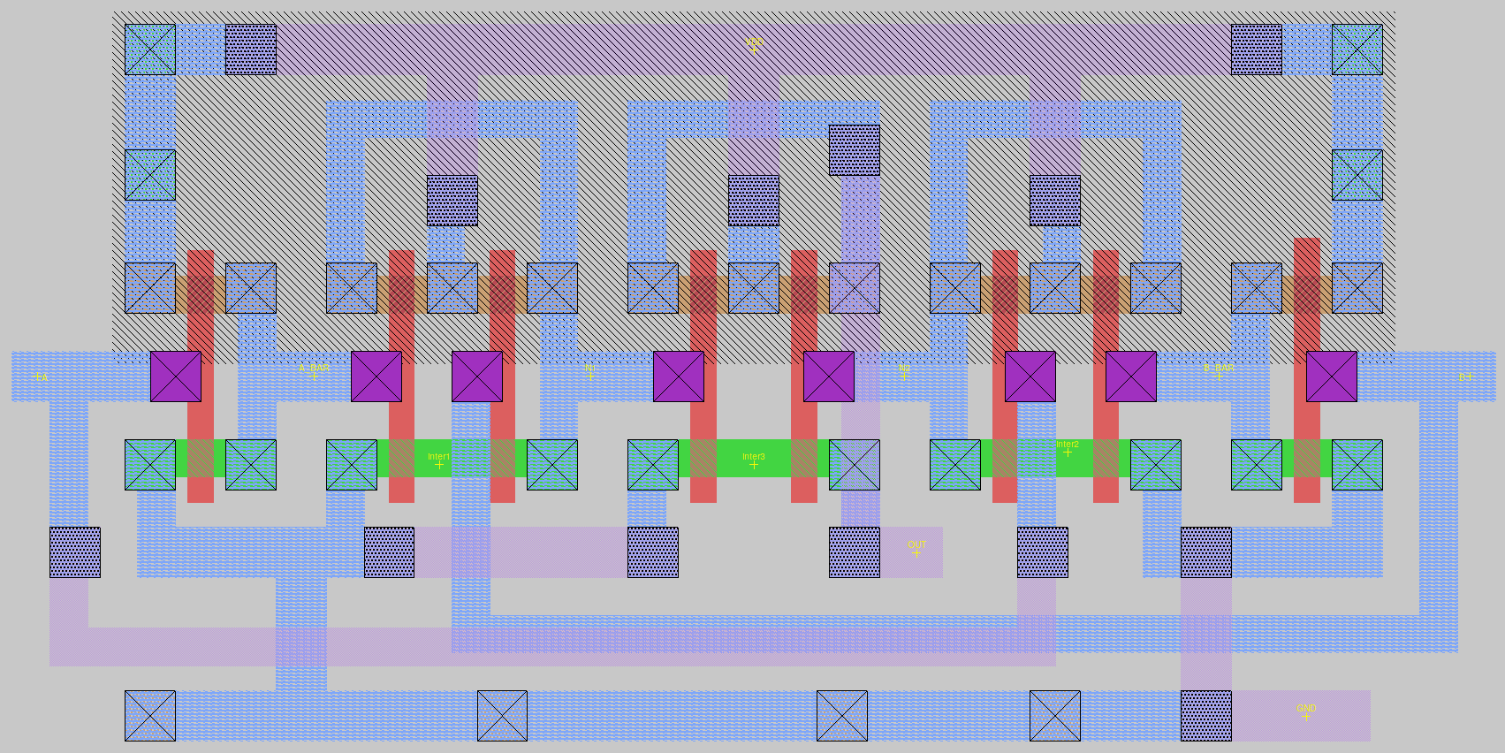
2-Input XOR Gate
OBSERVATIONS:

1. NAND Gate working for the possible inputs
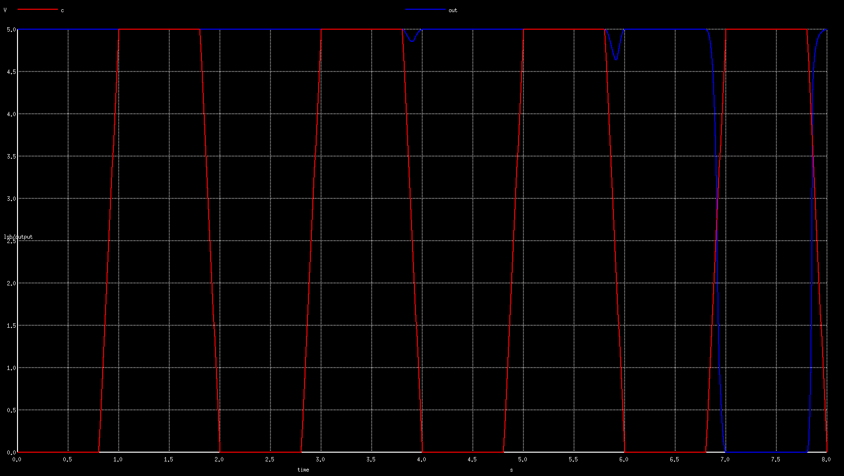
2. NOR Gate working with the possible inputs
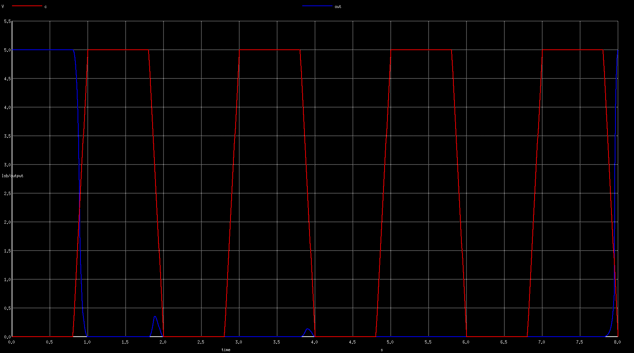

3. XOR Gate working with all the possible inputs
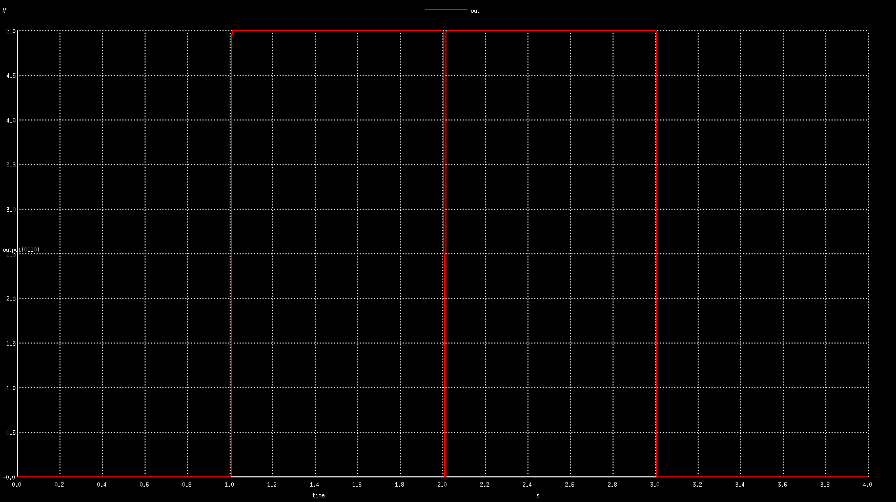
CONCLUSION:
The gates work as expected except for propagation delays due to non-ideal character

